INFORME
REPORT
TÍTULO  TITLE |  |  |  |  | NÚMERO DE INFORME  REPORT NUMBER
Residual Part Detachment Risk Assessment |  |  |  |  | 00503-00-ZIT003
NÚMERO DE PROYECTO  PROJECT NUMBER |  | NOMBRE DE PROYECTO  PROJECT NAME |  |  |  | PÁGINAS TOTALES  TOTAL PAGES
00503 |  | GRIS |  |  |  | 8
DATOS DEL CLIENTE
CUSTOMER DATA
NAME: Mecanalisis internal project
PLANT: -
CITY: -
UNIT: -
REFERENCE NUMBER: -
REVISIÓN  REVISION | DESCRIPCIÓN DE LA REVISIÓN  REVIEW DESCRIPTION
00 | Initial issue
REGISTRO DE CAMBIOS DEL INFORME
REPORT CHANGE LOG
REV  REV | PREPARÓ  PREPARED |  | REVISÓ  REVISED | APROBÓ  APPROVED |  |  | FECHA  DATE
00 | Matias Gaviño |  | Carlos Caceres | - |  |  | 13/04/2026

TABLE OF CONTENTS
1. OBJECTIVES 3
2. INTRODUCTION 3
3. ASSESSMENT METHOD 3
4. ASSESSMENT SCALES 4
4.1. Likelihood 4
4.2. Multiplicity factor 4
4.3. Consequence severity 4
4.4. Residual risk classification 5
5. ASSESSMENT RESULTS 6
5.1. Position Identification 6
5.2. Residual Risk Assessment by Position 7
6. CONCLUSION 8

- OBJECTIVES
- Assess the residual risk associated with potential part detachment in the GRIS robot during operation.
- Define the residual risk classification for each assessed item for generator inspection service.
- Document the assessment method, rating criteria, and acceptance basis used in the evaluation.
- INTRODUCTION
Any detached or loosened part inside a generator represents a serious event, with the potential to damage internal components, reduce machine availability, and require recovery actions before return to service. Preventing this condition was therefore established as a primary design criterion throughout the development of the GRIS robot. Accordingly, the system was designed with specific retention, containment, and verification measures to minimize this risk. Nevertheless, as with any engineered system, a residual risk remains. This report assesses that residual risk for components that could detach during operation and formally documents the resulting evaluation.
- ASSESSMENT METHOD
This assessment was performed as a residual risk evaluation of the released GRIS configuration. It assumes that the implemented retention, containment, and verification measures are already in place and effective under the standard service process, including application of the standard pre-test and post-test inspection checklist defined in document 00503-00-ZRQ001.
Each assessed item was evaluated independently, based on its specific detachment concern, implemented control measures, and potential consequence if the item were to remain inside the generator. The assessment does not treat the robot as a single generic assembly; instead, each item is considered as an individual case.
The numerical ratings were assigned by an expert committee with expertise in generator systems and robotics, using engineering judgment based on the reviewed design, implemented retention features, inspection criteria, and available validation evidence. The rating process considered the expected behavior of each item under normal operation.
The residual risk score is calculated as:
R = L × M × S
where:
L = likelihood of detachment
M = multiplicity factor, representing the number of identical instances
S = consequence severity, representing the potential damage if the machine were started with the assessed item still inside
This is a semi-quantitative engineering assessment, not a statistical failure-rate calculation. Its purpose is to provide a structured and technically justified comparison of the reviewed items and to determine whether the residual risk remains within the acceptable range for operation.
Acceptance is based on the resulting residual risk classification. Only items rated Very Low or Low are considered acceptable for the released configuration. Any higher classification requires additional review or mitigation.

- ASSESSMENT SCALES
  - Likelihood
Value | Classification | Definition
0.1 | Extremely Remote | Detachment is not considered credible under normal service conditions. It would require the failure of multiple independent barriers or an abrupt, unexpected break. Mechanical retention is maintained across all operating states.
0.5 | Very Remote | Detachment is highly improbable under normal service conditions. It would require the failure of at least two independent retention features or a very localized loss of retention.
1.0 | Remote | Detachment is remotely possible under normal service conditions. The item is fixed, non-adjustable between operations, and defined measures are in place to prevent loosening or release.
2.0 | Unlikely | Detachment is improbable under normal service conditions. The item is manipulated during operation or service, but defined measures are in place to prevent loosening or release.
3.0 | Possible | Detachment is possible under normal service conditions because the item lacks sufficient retention features or relies on a single control barrier.
  - Multiplicity factor
Value | Classification | Definition
1.0 | Low Multiplicity | 1–2 identical instances of the assessed item could be affected by the same failure mode.
2.0 | Medium Multiplicity | 3–5 identical instances of the assessed item could be affected by the same failure mode.
3.0 | High Multiplicity | >5 identical instances of the assessed item could be affected by the same failure mode.
  - Consequence severity
Value | Classification | Definition
0.1 | Negligible | No damage is expected. Recovery of the item is not required.
0.5 | Minor | Visible marks or superficial damage may occur, but machine functionality is not expected to be affected. The item may remain in place, although removal should be considered.
1.0 | Moderate | Minor damage may occur. The item must be removed.
2.0 | Major | Significant damage is expected. The item must be removed.
3.0 | Catastrophic | Catastrophic damage is expected. The item must be removed.

  - Residual risk classification
Range | Classification | Definition | Acceptability
0 < R ≤ 1.0 | Very Low | No additional action required beyond implemented controls and standard verification. | Acceptable
1.0 < R ≤ 2.0 | Low | Maintain implemented controls and apply focused attention during routine inspections. | Acceptable
2.0 < R ≤ 4.0 | Moderate | Further justification or strengthened controls are required before release. | Not acceptable
4.0 < R ≤ 6.0 | High | Additional mitigation is required before release. | Not acceptable
R > 6.0 | Very High | Redesign or additional mandatory barriers are required before release. | Not acceptable

- ASSESSMENT RESULTS
  - Position Identification
The following figures identify the assessed positions on the GRIS robot used throughout this report and in the associated inspection checklist. Figure 1 shows the isometric top view, and Figure 2 shows the isometric bottom view.
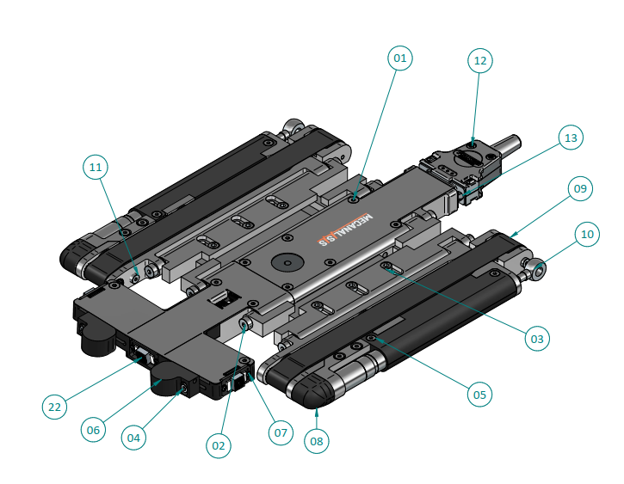
Figure 1. Position identification - GRIS isometric top view.
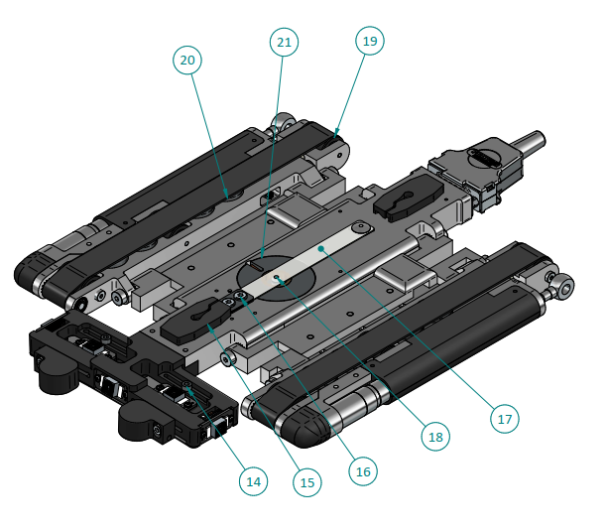
Figure 2. Position identification - GRIS isometric bottom view.
  - Residual Risk Assessment by Position
The following table presents the residual risk assessment results for each assessed position in the GRIS robot:
Pos. | Item | Detachment concern | Implemented controls | L | M | S | R | Class
1 | Cover retaining screw | Backing out | Threadlocker + Torque mark + Retention tape over screw set | 1.0 | 3 | 0.5 | 1.5 | Low
2 | Module joining shoulder screw | Backing out | Torque control | 0.5 | 3 | 1.0 | 1.5 | Low
3 | Extender retaining screw | Backing out | Mechanical retention + Threadlocker + torque mark | 0.1 | 1 | 1.0 | 0.1 | Very Low
4 | ELCID magnetic sensor fastening screw | Backing out / Pull-out | Mechanical retention | 0.1 | 1 | 1.0 | 0.1 | Very Low
5 | Motor cover screw | Backing out / Pull-out | Threadlocker + torque mark + Retention tape over screw set | 0.5 | 3 | 1.0 | 1.5 | Low
6 | ELCID magnetic sensor | Fracture | Material integrity inspection | 0.5 | 1 | 1.0 | 0.5 | Very Low
7 | Camera retaining screw | Backing out / Pull-out | Threadlocker + Torque mark | 1.0 | 3 | 0.5 | 1.5 | Low
8 | Gear cover | Fracture / Disengagement | Fit retention + Retention tape | 1.0 | 1 | 0.1 | 0.1 | Very Low
9 | Track belt | Derailment | Validated track confinement; full derailment not credible | 1.0 | 1 | 1.0 | 1.0 | Very Low
10 | Recovery hook | Backing out / Pull-out | Threadlocker + Torque mark | 0.1 | 1 | 2.0 | 0.2 | Very Low
11 | Wheel axle shoulder screw | Backing out | Threadlocker + Torque mark | 0.5 | 2 | 2.0 | 2.0 | Low
12 | Main connector housing screws | Backing out | Threadlocker + Torque mark + Retention tape over screw set | 0.5 | 2 | 1.0 | 1.0 | Very Low
13 | Main connector latch screws | Backing out | Mechanical retention | 0.1 | 1 | 1.0 | 0.1 | Very Low
14 | Bottom camera position locking screw | Backing out | Mechanical retention | 0.1 | 1 | 1.0 | 0.1 | Very Low
15 | Central slot guide | Disengagement | Fit retention | 2.0 | 1 | 0.5 | 1.0 | Very Low
16 | Leaf spring retaining screw | Backing out | Threadlocker + Torque mark | 2.0 | 1 | 1.0 | 2.0 | Low
17 | Leaf spring | Fracture | Material integrity inspection | 1.0 | 1 | 1.0 | 1.0 | Very Low
18 | Impactor grub screw | Backing out | Threadlocker + Retention tape | 3.0 | 1 | 0.1 | 0.3 | Very Low
19 | Track wheels | Fracture | Material integrity inspection | 0.1 | 2 | 0.5 | 0.1 | Very Low
20 | Magnets retaining screw | Backing out | Threadlocker + Torque mark | 0.5 | 2 | 2.0 | 2.0 | Low
21 | Impact solenoid | Detachment | Mechanical retention + Interference fit | 0.1 | 1 | 3.0 | 0.3 | Very Low
22 | Camera lens | Backing out | Adhesive bond | 3.0 | 1 | 0.1 | 0.3 | Very Low

- CONCLUSION
The assessed GRIS configuration remains within the acceptable residual risk range for generator inspection service. All reviewed items were classified as either Very Low or Low, and no item reached a Moderate or higher risk level. The highest residual risk score obtained was 2.0, which remains within the acceptable range.

Based on this assessment, no additional mitigation is required for the released configuration prior to service. This conclusion remains valid only for the reviewed GRIS configuration, its implemented controls, and the current standard verification process. Any relevant design, retention, operating, or verification change shall require reassessment.

